**KARNATAK UNIVERSITY**



Project Report On

## EASY LEAVE

## A leave management software.

**Submitted**

**By**

**Mr. Pavankumar Vishnu Naik**

**Reg No: 20U12917**

Submitted in partial fulfillment for the award of the degree

**“BACHELOR OF COMPUTER APPLICATION”**

**Under the Guidance of**

**Internal Guide**

**Mr. Anurag Naik**

HOD of Kamadhenu BCA College

**External Guide**

**Mr. Satish Naik**

Faculty of Sathyam Computer Education

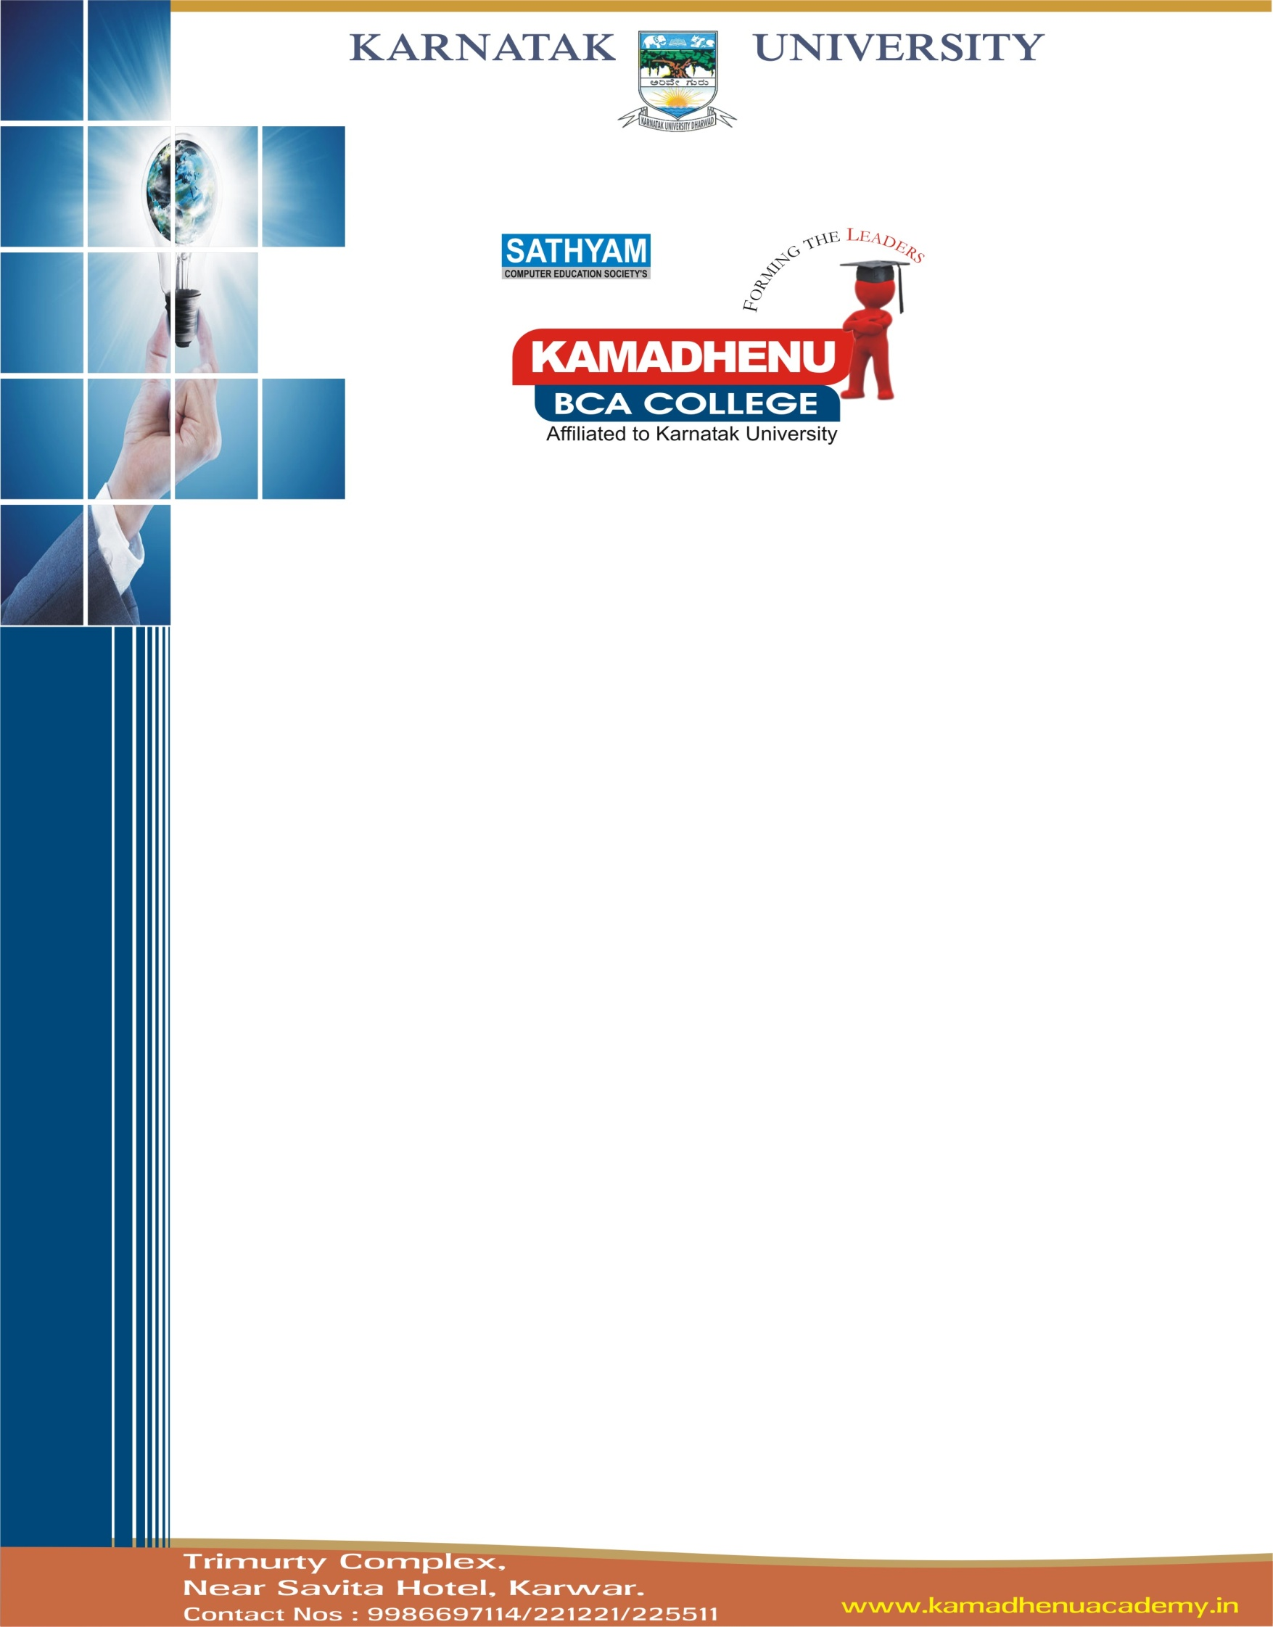

**Reg. No: 20U12917**

|  |  |
| --- | --- |
| **External Guide** |  |
| Mr. Satish Naik |  |
| Faculty of Sathyam Computer Education | **External Examiner** |
|  |  |
|  |  |
| **Internal Guide** |  |
| Mr. Anurag Naik  HOD Kamdhenu BCA College | **Internal Examiner** |
|  |  |
|  |  |
|  |  |
|  | **Principal** |
|  |  |

**Certificate**

This is to certify that Mr. **Pavankumar Vishnu naik** bearing Registration No: 20U12917 has satisfactorily completed the project work entitled **“Easy leave a leave management software”** towards the partial fulfillment of the requirements for the award of the degree of Bachelor of Computer Application, Prescribed by Karnataka University Dharwad, for the academic year 2022-23.

**From,**

Vishnu T naik

Ratnagiri – 415 612

**To,**

The principal

Kamadhenu BCA College

Krishna Complex, Top floor

Karwar- 581301

**Project Completion Certificate**

This is to certify that **Mr. Pavankumar Vishnu naik** Reg. No **20U12917** student of BCA V Semester of Kamadhenu BCA College has undergone his project name **“Easy Leave – A leave management software”** for case management has completed successfully.

During this project his behavior was good and we are very thankful to him and I wish him all the very best her life ahead.

Date:

Place: Signature of the client Vishnu T Naik

**DECLARATION**

I hereby declare that this project work titled “**Easy Leave – A leave management software**” software is my original work and no part of it has been submitted for any other degree purpose or hosted in any other form till date.

**Pavan V Naik**

**ACKNOWLEDGEMENT**

I am very much glad, for the successful completion of my project. Any task would be incomplete without greeting those who made it possible and encouragement made the efforts taken a success. It gives me immense pleasure and satisfaction to introduce the completion of my hard-work and sincere dedication entitled

**“Easy Leave – A leave management software”**

I thank God for his blessings. I am greatly indebted to my parents for showering me with their constant love and affection. This project is not just my effort, but also many other peoples who have helped me in some or the other way effort, but also many other peoples who have helped me in some or the other way to complete this work. So here is my humble attempt at expressing my gratitude those well-wishers.

I express our sincere thanks and gratitude **Mr.** **Satish** **Naik,** Principal of Kamadhenu BCA College Karwar, for providing all provisions for studies during the entire course.

I would like to express our gratitude and indebtedness to my external guide **Mr**. **Satish** **Naik** of Sathyam Computer Education Karwar, for his valuable advice and guidance without which this project would not have seen the light of the day. It gives us immense pleasure to avail this opportunity to thank my internal guide **Mr. Anurag Naik.**

I wish to express deep sense of gratitude to **Mr. Satish Naik,** Proprietor for providing their great support. And lastly, I also heartily thank all staff members who have directly or indirectly helped us by extending by their invaluable support and encouragement in completing the project.

My hearty thanks go to my friend, Ganesh Naik for helping for the completion of my project.

**Pavan V naik**

Reg. No: 20U12917

**Project is**

**Dedicated to my Beloved Parents.**

Dear Parents,

Thanks for always being there for me, love me, care for me, no one can ever replace you in my life.